# __EXTERNAL NOTES__

*The form below is filled out by the Insights and Analytics team using information from our customers and intake form.*

**Project Scoping: Project ID 008: *Ikea Design Studio***

Last Updated: **2021.05.17**

|  |  |
| --- | --- |
| Customer Name: | *Brad Breitling* |
| Challenge/Concept: | ***We would like for Ikea to bring their Design Studio concept to our centers.*** |
| Objective: | ***We believe that the following point would provide a convincing argument:***   * ***That our customer base is amenable to their desired population and therefore becoming a tenet would bring their desired customer. (Population growth, net migration…)***   ***Ultimately would love to show: “there’s significant demand for this to be valuable” and “Look at all these similarities between Tanger and Ikea”*** |
| Definition of Success: | ***This project will result to addressing the enterprise goals of “bringing a high profile/ targeted tenant into our portfolio”.***  ***Furthermore, successfully getting Ikea would help to meet the Leasing Team’s 2021 goals of leasing ... sf (goal not yet formally set)*** |
| Proposed output: | ***To help provide a convincing proposal, the Insights and Analytics team will provide the Leasing team with a slide deck with the recommended centers*** |
| Proposed timeline: | * ***Start Date: 2021.05.11***   + ***Kick off + Receive Ikea demographics from Brad***   + ***Perform Analysis***     - ***Develop demographic characteristic for Ikea***       * ***Develop benchmarks with Babbage***       * ***Compare Ikea desired vs Ikea actual population***     - ***Using the ESRI to find top indexing centers for “Household Furnishing”, “Household Textiles” and “Housewares”, with 60-mile radius***     - ***Why Tanger, Why Now: Centers with positive migration in (2020), compared to 2017***     - ***Develop presentation and send to team as read-out***       * ***Provide recommended centers*** * ***Delivery Date: 2021.05.27*** * ***Follow up/ Lessons Learned: 2021.06.07***   + ***What landed well with Ikea? What didn’t?*** |

**Notes:**

Brad has been talking to Ikea for several years now, and while historically they’ve been less receptive, he’s thinking the Design Studio concept could be a good in.

* They are only looking to consider this in their top metro markets (**NY, DC**, Chicago, LA)
* “We are just trying to refresh the conversation and get them talking”

*Questions for Discussion…*

How focused on Deer Park do we want to be?

* Is it just a nice to have with the possibility of double-dipping with FilLogic?
  + Are there other centers we are looking for?
* Is there are requirement of proximity to a distribution center?

Would we want to mirror centers who see similar demographics with large Ikea stores?

* Are we instead looking for centers who capture a different demographic?
  + Probably would want centers that are less touristy..
    - Trying to attract the local shoppers (shopping for home)?

Can we point to halo affect for Ikea specifically? **>> Delay on going down this path for now (5/11)**

* Probably not... maybe citing ICSC/Babbage paper from 2018/2019 would be helpful for this pitch?
  + Could connect with Babbage to understand if this is something we could dig into/ measure for Ikea
* Is one of Ikea’s current goals to increase their digital presence?
  + 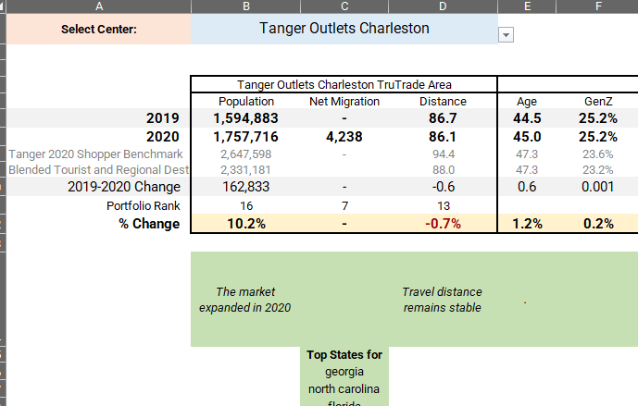The halo affect pitch might not land unless this was something Ikea was looking for…

Using Babbage “Why Tanger Why Now” tool to understand net migration

* Help to characterize locations with positive growth

Understanding the press coverage

* Connecting with Quentin to gather press information

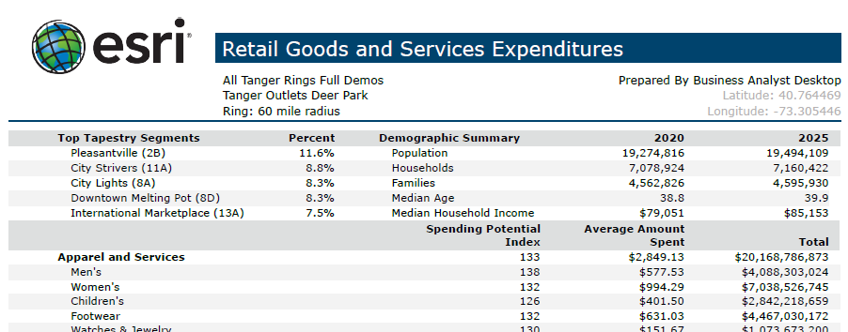Using ESRI’s SPI (Spending potential index)

* *Data Note: The Spending Potential Index (SPI) is household-based, and represents the amount spent for a product or service relative to a national average of 100*

Showing… That opening this Design Studio would serve the entire digital + physical ecosystem (Ikea + Tanger + FilLogic?)

# __INTERNAL NOTES__

*These items are not shared with our customers as they pertain to the internal mechanisms/ process.*

Project location: *g:/study/008_20210505_Sales_Ikea*

Data elements required:

Assumptions made:

Project Owner: Phil Walker

**__Project Close Out__**

Lessons learned:

How were the results received?

Notes from intake form

Please describe your request-

We are working with Ikea on a new concept they are testing for a 800 sf Design Studio where the customer can come and meet with a consultant, view vignettes in a showroom and order a custom kitchen or what have you. We believe there are some additional benefits to add to this concept and want to put together a pitch as we are trying to set up an executive level meeting. Here is what we are thinking:

• It is our assumption that our customer and the Ikea customer align well. Can we prove this? I am requesting the customer demos from Ikea.  
• We believe these design centers will increase online engagement in the market. Aka the halo effect. Can we prove that?  
• We believe the test case should be Deer Park and that we should leverage Fillogic to assist with Deer Park becoming a e-com pick up location, with their store in Brooklyn acting as the warehouse of inventory.

Goal date >> 5/27/2021: Because I have a call with IKEA the following week.

Notes from initial research

IKEA - overview

<https://www.statista.com/topics/1961/ikea/#dossierSummary>

Planning Studio

<https://www.ikea.com/us/en/stores/planning-studio-upper-east-side/#13de3220-665e-11eb-ac53-e935475a4ead>

open questions…

How focused on Deer Park do we want to be?

* Is it just a nice to have with the possibility of double-dipping with FilLogic?
  + Are there other centers we are looking for?
* Is there are requirement of proximity to a distribution center?

Would we want to mirror centers who see similar demographics with large Ikea stores?

* Are we instead looking for centers who capture a different demographic?
  + Probably would want centers that are less touristy..
    - Trying to attract the local shoppers (shopping for home)?

Can we point to halo affect for Ikea specifically?

* Probably not?... maybe just citing ICSC paper from 2018/2019
  + Surprising numbers were cited in it though…
* Is one of Ikea’s current goals to increase their digital presence?